Morne du Toit

GYGVF2448

**Lecturer: Micheal Duve**

**March/April 2021**

ITECA3  
Deliverable 1

# Project Proposal

**Student name:** Morne du Toit

**Student Number:** GYGVF2448

**Project Title:** Hout E-Commerce

**Submission Date:** 7 April 2021

# Table of contents

Project Proposal **1**

Table of contents **2**

1.1 Introduction **3**

1.2 Needs/Problems **3**

1.3 Goal Objectives **3**

1.4 Procedures/Scope of work **4**

1.5 Time Table **6**

1.6 Budget **6**

1.7 Key Personnel **7**

1.8 Conclusion **7**

1.9 Sign-off **8**

# 1.1 Introduction

The client runs a small furniture business, called Hout, in which he locally manufactures his furniture, in the past, he would sell his products at local markets which would result in the client receiving a small profit margin. However, he would like to expand his business by first selling domestically and then globally, ensuring that the client maximises their profits.

He plans to hire more staff to help him, but first, he would need to advertise to a new extension of customers, which currently seem impossible. Nevertheless, the client has decided to expand his business with an e-commerce site.

Thus, I have offered my services to code a website for the client to help him expand his business to a broader audience. The online store would also help him manage his orders and his sales.

# 1.2 Needs/Problems

The client struggles to supply his furniture outside of his local community. Therefore, he is trying to increase the area in which his products would reach and the amount that he can manufacture. He needs to reach a new clientele list and his current method of publishing ads in a newspaper is not getting the results as he wished.

The client only recently decided to enter the online market with his products. However, this could cause a rapid change to the way the client does business, meaning that he might not get the full use out of the new change to the business if he cannot adapt. He would need an online store that can sell his variety of products easily to anyone in the world, he would need to arrange to ship for every order, he might even need to adapt his furniture designs to make sure that the shipping can be improved. He also requires the ability to add new products on demand.

If the client’s business starts to grow, he might need a larger warehouse. Nevertheless, the client can now focus on a global strategy, he might lose the local community and thus it might impact his connection with customers. Which might be his main selling point and reason for people to do business with him.

However, the client can now provide simple and very accessible business to anyone who would require purchasing from the client’s business.

# 1.3 Goal Objectives

* To provide the client with an online store. In doing so the client could achieve his dream of expanding his business globally.
* Providing the client with an admin login so that they can easily add extra items and control their business details.
* The client would need his customers to sign up to capture their details, to ensure orders and purchases go smoothly.
* To provide a record of orders for the client so that he can keep track of his income.
* Role-based permissions on the website.
* The client’s customers would need to be able to create an account.
* The client’s customers would need to be able to see their history.
* A home page where clients can see the products available.
* The site would need to handle payments and order placements
* The client must be able to upload new products or remove existing ones as well as be able to edit the products
* The client would need to see a complete report of all his business activities.

# 1.4 Procedures/Scope of work

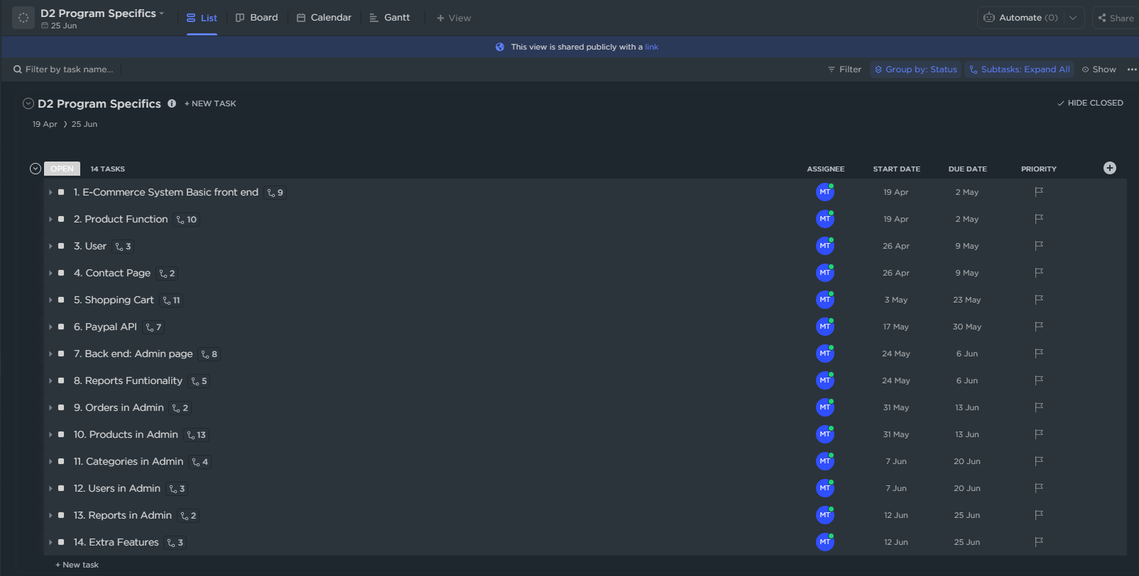

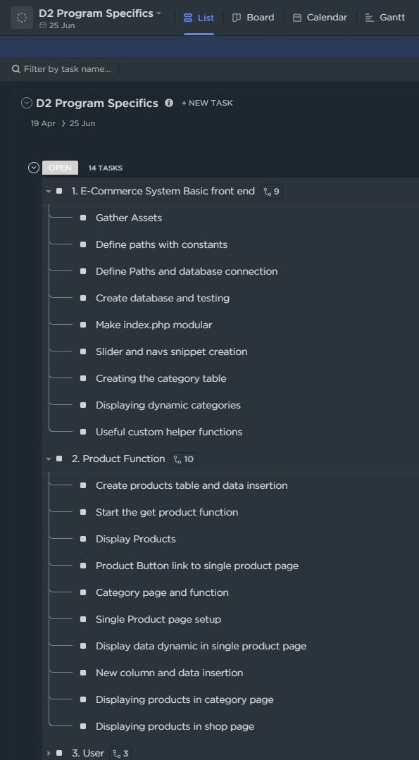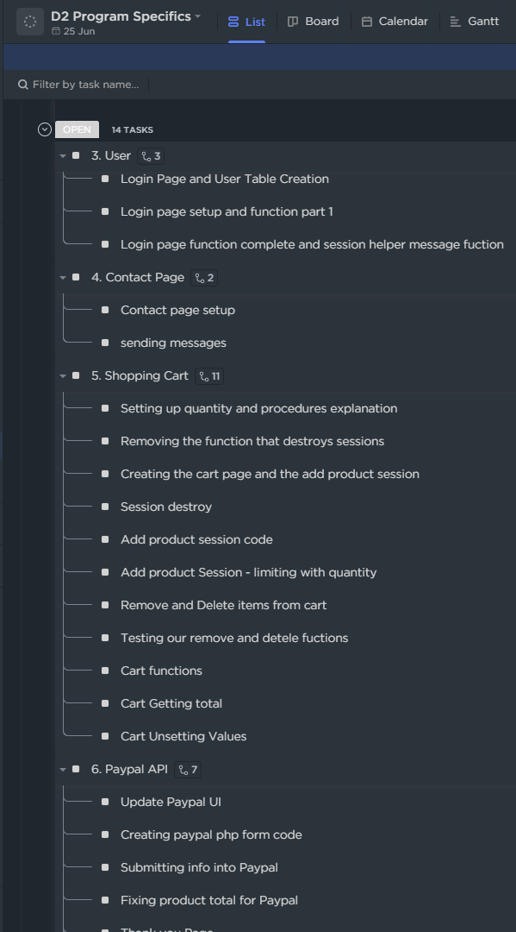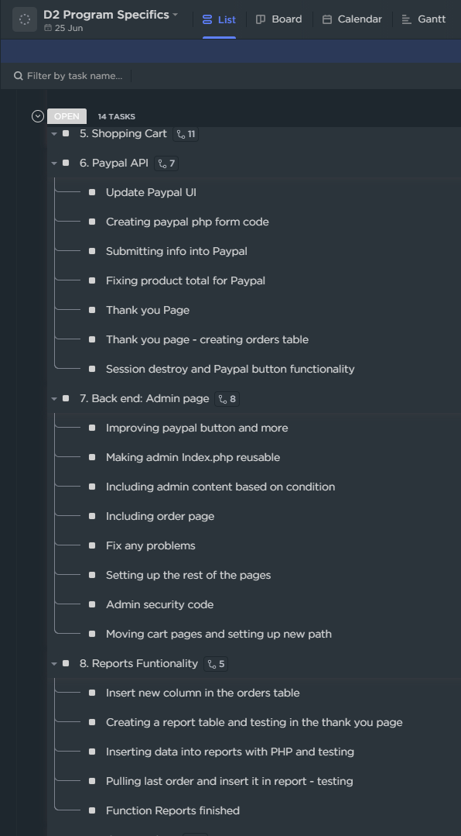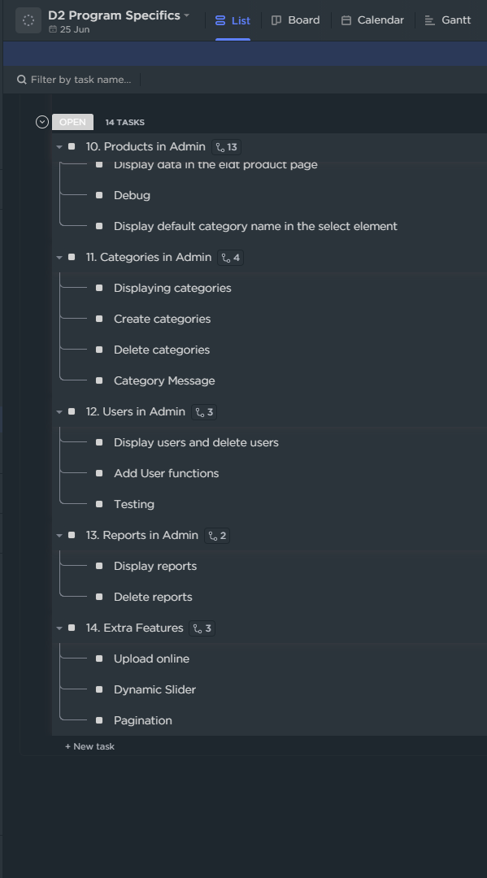

Please use the like below to see a live and interactive list of all the work required to build the eCommerce site.

Full scope available below.

<https://share.clickup.com/l/h/37yd0-46/86cb99fc3be6df9>

# 1.5 Time Table

|  | Description of Work | Start and End Dates |
| --- | --- | --- |
| Deliverable 1 | Project Proposal | 22 Mar ’21 – 2 Apr ‘21 |
| Deliverable 2 | Documentation and coding | 5 Apr 21’- 25 Jun ‘21 |
| Deliverable 3 | Presentation | 21 Jun ’21 – 2 Jul ‘21 |

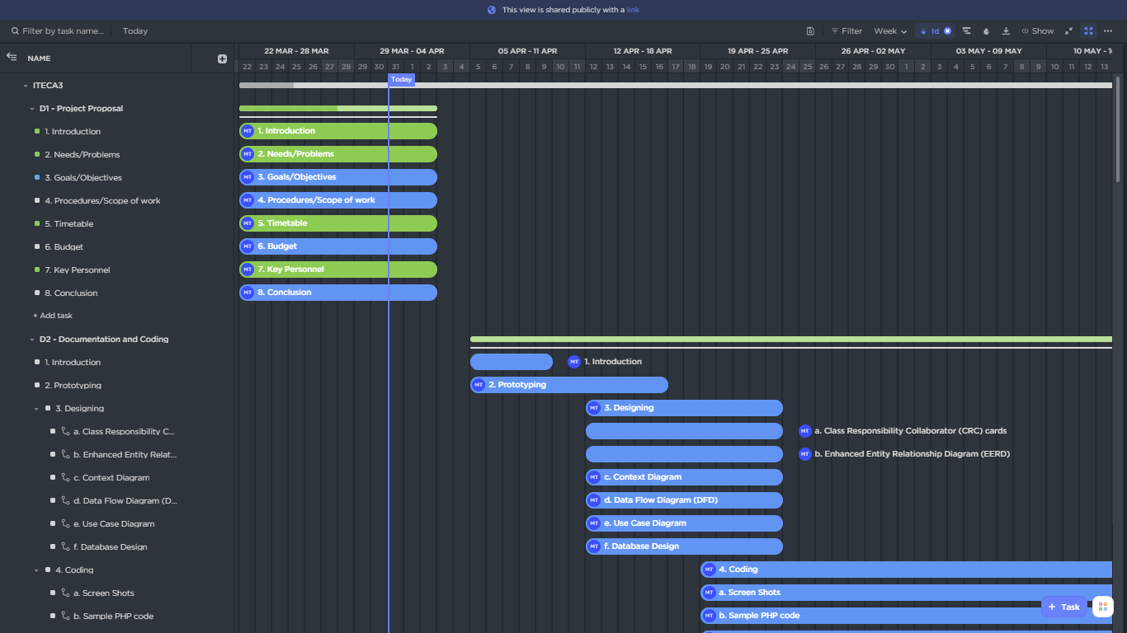

Please also make use of my live and interactive Gantt chart to see the full work spectrum.

Please note that all work marked as completed will not be visible on the link below.

<https://share.clickup.com/g/h/5-5427279-7/2ad070bf31709cb>

# 1.6 Budget

|  | Description of Work | Cost (R) |
| --- | --- | --- |
| Deliverable 1 | Project proposal | R20,000 |
| Deliverable 2 | Documentation and coding | R100, 000 |
| Deliverable 3 | Presentation | R0,00 |
|  | Total | R120, 000 |

# 1.7 Key Personnel

| Stakeholders | Name [and Company] | Contact Details |
| --- | --- | --- |
| Client | Ryan - Hout |  |
| Sponsor | Ryan - Hout |  |
| Project manager | Morne du Toit | 0748155147 |
| Team | Morne du Toit | |

# 1.8 Conclusion

To conclude, an eCommerce site would be needed to sell furniture locally and globally.

The site would need serval features like:

* Role-based permissions on the website.
* The client’s customers would need to be able to create an account.
* The client’s customers would need to be able to see their history.
* A home page where clients can see the products available.
* The site would need to handle payments and order placements
* The client must be able to upload new products or remove existing ones as well as be able to edit the products
* The client would need to see a complete report of all his business activities.

All of these requirements can be completed within the time frame.

# 1.9 Sign-off



|  |  |  |  |
| --- | --- | --- | --- |
| Ryan, Project Client      Date: 2 April 2021 |  |  | Morne du Toit, Project Manager      Date: 2 April 2021 |